Time After Pentecost
The Season of Parables – Year A
Setting 8
Sunday July 5th, 2026

St. Paul Lutheran Church
9844 SW Greenville Road
Greenville, MI 48838

Sharing the joy of Christ.


MUSIC BEFORE WORSHIP

WELCOME

REFLECTIVE MUSIC TO CENTER OURSELVES IN GOD
We listen in silence and receive the gift to prepare our hearts.

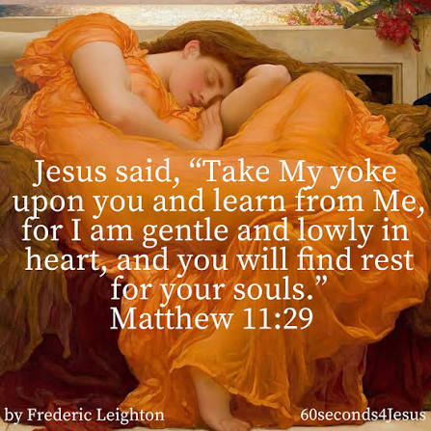

CONFESSION AND FORGIVENESS
All may make the sign of the cross, the sign that is marked at baptism, as the presiding minister begins.

Blessed be the holy Trinity, ☩ one God,
whose compassion endures forever.
Amen.

Let us confess our sin to God.

Silence is kept for reflection.

Compassionate God,
we confess to you all our sins.
Our burden is heavy, and we cannot free ourselves.
In your mercy, call us back to you.
Your yoke is easy and your burden is light.
Restore us to dwell in your peace.
In Christ’s name we pray,
Amen.

Jesus says, “Come to me,
all you who are weary
and are carrying heavy burdens,
and I will give you rest.”
In the name of the
Father, ☩ Son, and Holy Spirit,
your sins are forgiven.
Rest in God’s love.
Amen.


GATHERING HYMN ELW #697 JUST A CLOSER WALK WITH THEE
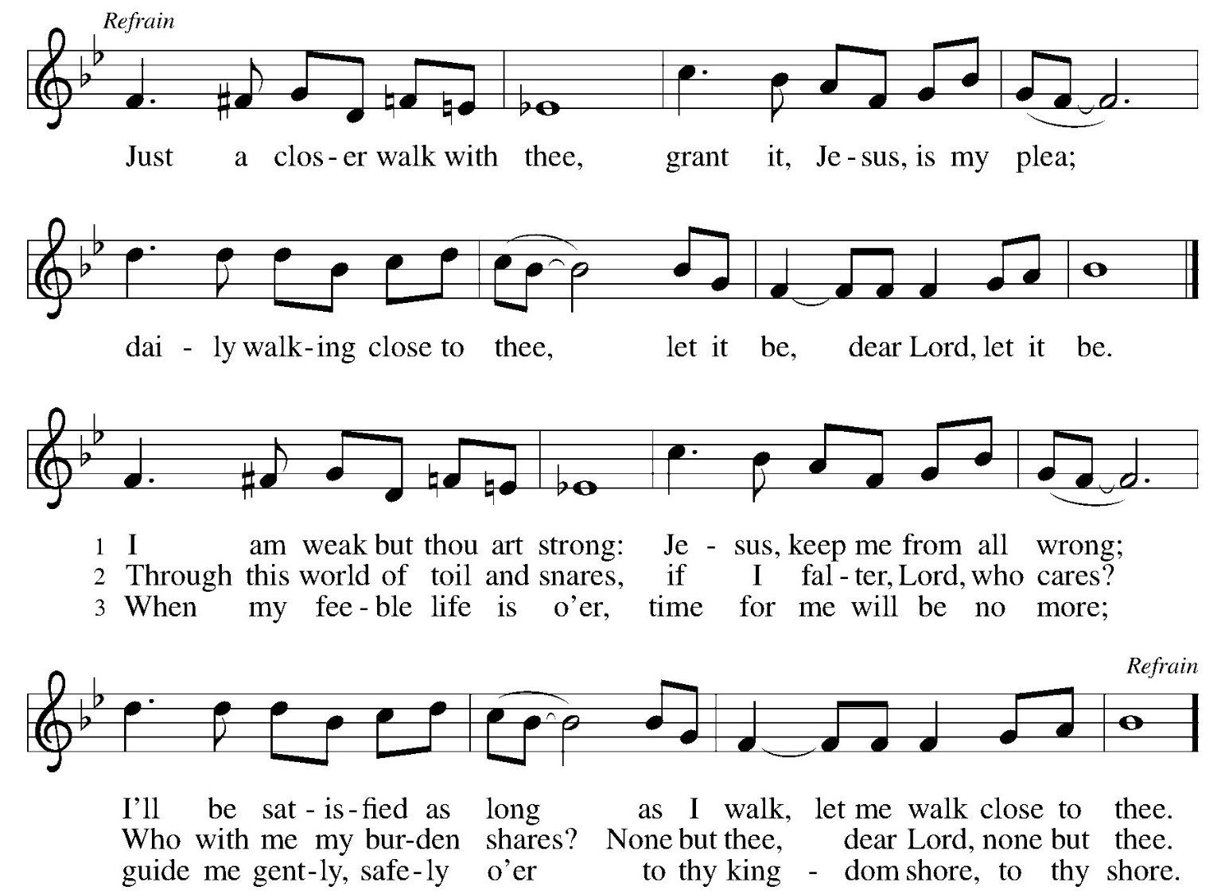

GREETING

The grace of our Lord Jesus Christ, the love of God, and the communion of the Holy Spirit be with you all.
And also with you. (hands out)
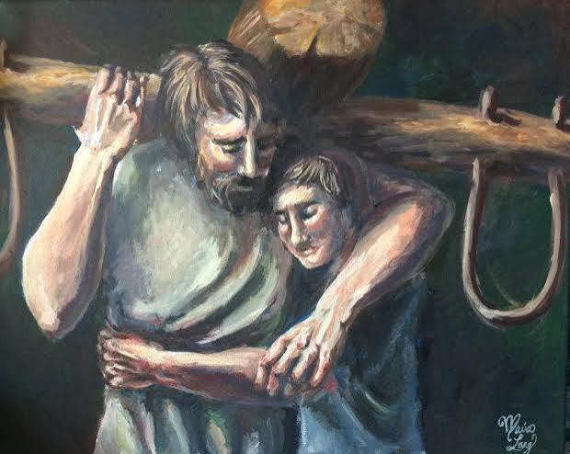
KYRIE
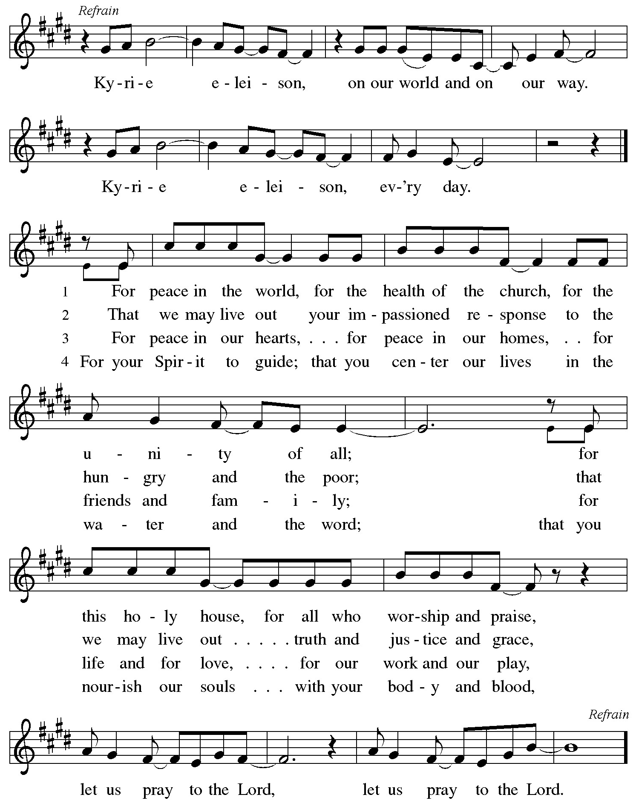
THIS IS THE FEAST

This is the feast of vict’ry for our God,
for the Lamb who was slain has begun his reign. Alleluia.
Worthy is Christ, the Lamb who was slain,
whose blood set us free to be people of God.
Power, riches, wisdom, and strength,
and honor, blessing, and glory are his.
This is the feast of vict’ry for our God,
for the Lamb who was slain has begun his reign. Alleluia.
Sing with all the people of God,
and join in the hymn of all creation:
Blessing, honor, glory and might
be to God and the Lamb forever. Amen.
This is the feast of vict’ry for our God,
for the Lamb who was slain has begun his reign. Alleluia.

PRAYER OF THE DAY

Let us pray.

A brief silence is kept before the prayer.

You are great, O God, and greatly to be praised. You have made us for yourself, and our hearts are restless until they rest in you. Grant that we may believe in you, call upon you, know you, and serve you, through your Son, Jesus Christ, our Savior and Lord.
Amen.
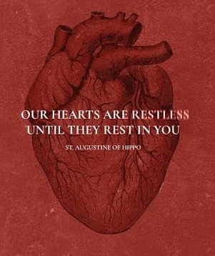
FIRST READING Zechariah 9:9-12

A reading from Zechariah. (pause)

⁹ Rejoice greatly, O daughter Zion!
Shout aloud, O daughter Jerusalem!
See, your king comes to you;
triumphant and victorious is he,
humble and riding on a donkey,
on a colt, the foal of a donkey.
¹⁰ He will cut off the chariot from Ephraim
and the war horse from Jerusalem;
and the battle bow shall be cut off,
and he shall command peace to the nations;
his dominion shall be from sea to sea
and from the River to the ends of the earth.
¹¹ As for you also, because of the blood of my covenant with you,
I will set your prisoners free from the waterless pit.
¹² Return to your stronghold, O prisoners of hope;
today I declare that I will restore to you double.

This is the word of the Lord.
Thanks be to God.

PSALM 145:8-14

⁸ The Lord is gracious and merciful,
slow to anger and abounding in steadfast love.
⁹ The Lord is good to all,
and his compassion is over all that he has made.
¹⁰ All your works shall give thanks to you, O Lord,
and all your faithful shall bless you.
¹¹ They shall speak of the glory of your kingdom
and tell of your power,
¹² to make known to all people your mighty deeds
and the glorious splendor of your kingdom.
¹³ Your kingdom is an everlasting kingdom,
and your dominion endures throughout all generations.
The Lord is faithful in all his words
and gracious in all his deeds.
¹⁴ The Lord upholds all who are falling
and raises up all who are bowed down.
SECOND READING Romans 7:15-25a

A reading from Romans. (pause)

15 I do not understand my own actions. For I do not do what I want, but I do the very thing I hate. 16 Now if I do what I do not want, I agree that the law is good. 17 But in fact it is no longer I who do it but sin that dwells within me. 18 For I know that the good does not dwell within me, that is, in my flesh. For the desire to do the good lies close at hand, but not the ability. 19 For I do not do the good I want, but the evil I do not want is what I do. 20 Now if I do what I do not want, it is no longer I who do it but sin that dwells within me.

21 So I find it to be a law that, when I want to do what is good, evil lies close at hand. 22 For I delight in the law of God in my inmost self, 23 but I see in my members another law at war with the law of my mind, making me captive to the law of sin that dwells in my members. 24 Wretched person that I am! Who will rescue me from this body of death? 25 Thanks be to God[a] through Jesus Christ our Lord!

This is the word of the Lord.
Thanks be to God.

CHILDREN’S MESSAGE

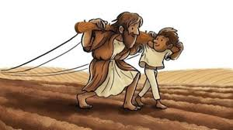
GOSPEL ACCLAMATION

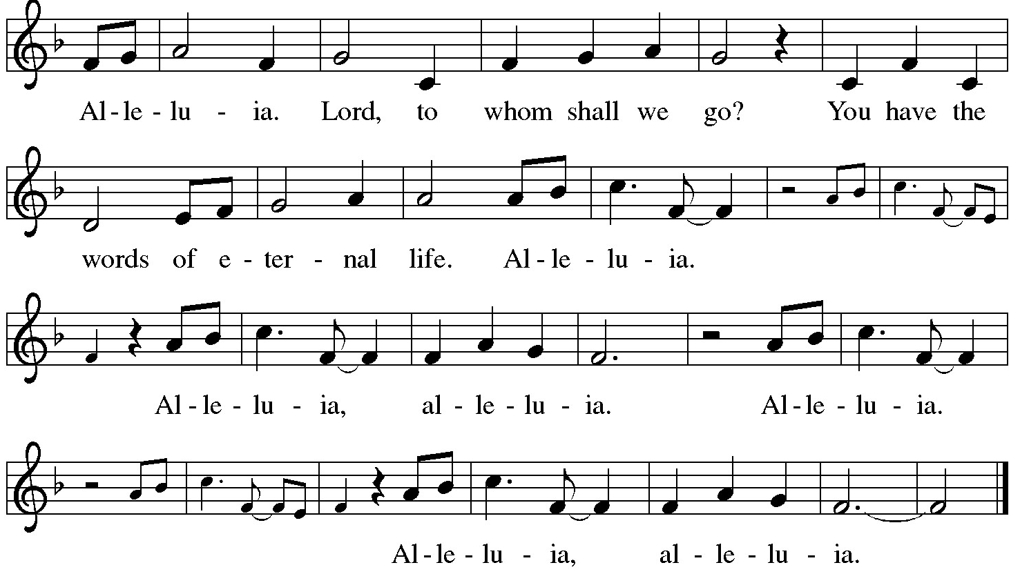

GOSPEL Matthew 11:16-19, 25-30

The holy gospel according to Matthew.
Glory to you, O Lord.

¹⁶ “But to what will I compare this generation? It is like children sitting in the marketplaces and calling to one another,
¹⁷ ‘We played the flute for you, and you did not dance;
we wailed, and you did not mourn.’
¹⁸ “For John came neither eating nor drinking, and they say, ‘He has a demon’; ¹⁹ the Son of Man came eating and drinking, and they say, ‘Look, a glutton and a drunkard, a friend of tax collectors and sinners!’ Yet wisdom is vindicated by her deeds.”
²⁵ At that time Jesus said, “I thank you, Father, Lord of heaven and earth, because you have hidden these things from the wise and the intelligent and have revealed them to infants; ²⁶ yes, Father, for such was your gracious will.^{[b]} ²⁷ All things have been handed over to me by my Father, and no one knows the Son except the Father, and no one knows the Father except the Son and anyone to whom the Son chooses to reveal him.
²⁸ “Come to me, all you who are weary and are carrying heavy burdens, and I will give you rest. ²⁹ Take my yoke upon you, and learn from me, for I am gentle and humble in heart, and you will find rest for your souls. ³⁰ For my yoke is easy, and my burden is light.”

The gospel of the Lord.
Praise to you, O Christ.

SERMON


This art is not presentation clean, but the focus on walking together with Christ is spot on.

HYMN OF THE DAY ELW #777 COME TO ME, ALL PILGRIMS THIRSTY
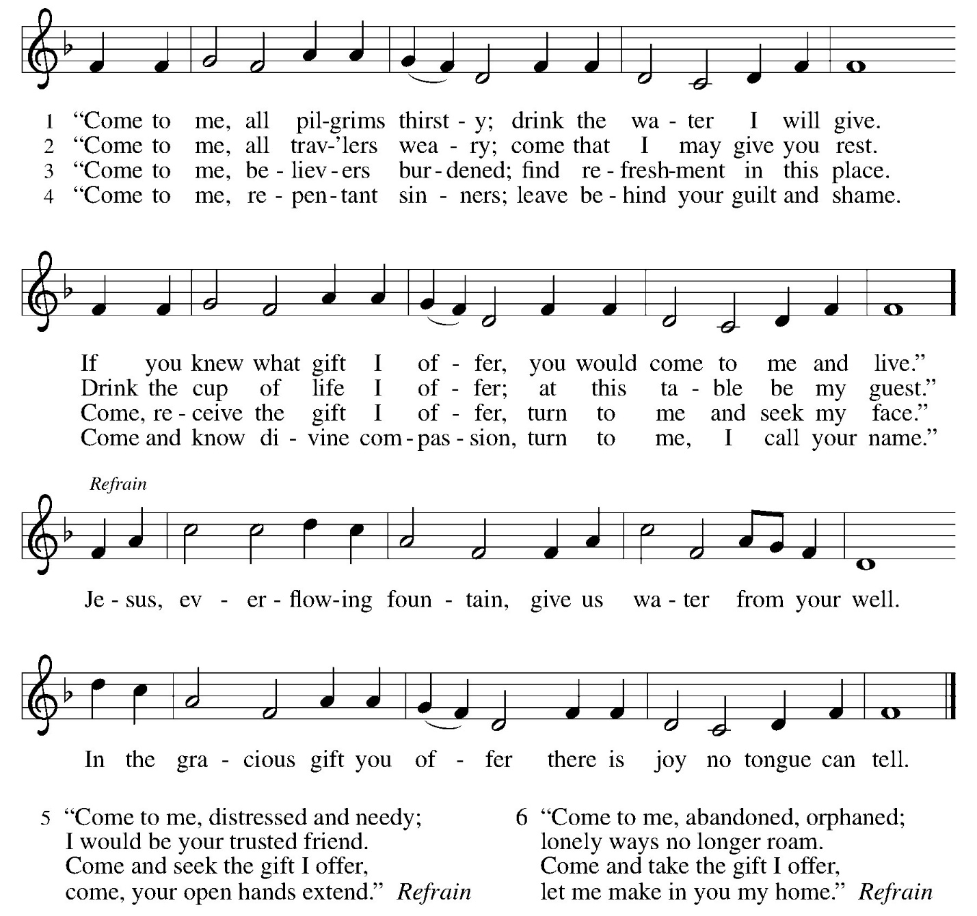

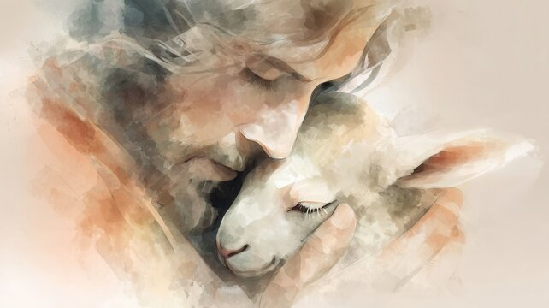
PRAYERS OF INTERCESSION

trusting in God’s steadfast love for all God has made, let us pray for the church, the world, and all of creation.

A brief silence.

God our unity, your church flourishes in different languages, cultures, and movements. Grant us wisdom to discern when our yokes are too heavy, that we may live and serve in the freedom of your rest.
God of grace,
Hear our prayer.

God our life-giver, we grieve the pains placed upon our common home through war and neglect. What you have lovingly crafted, guide us to lovingly tend.
God of grace,
Hear our prayer.

God our freedom, you are no tyrant but bring peace. As this nation marks its declaration of independence, teach us our part in announcing peace for future generations.
God of grace,
Hear our prayer.

God our comfort, liberate all in our community who are captive to fear, who have become isolated or ill, or who are in any need. We especially lift prayers for…
God of grace,
Hear our prayer.

God our guide, we do not always have the strength to do the good we wish to do. Free us from the cycles of violence that bind us, that all know your liberation.
God of grace,
Hear our prayer.

God our home, you model freedom through the love shared across communities of trust and goodwill. As we remember those now gone to eternal rest, we thank you for the gifts of life together.
God of grace,
Hear our prayer.

Grateful for your abundant provision and trusting in your goodness, we cast all our cares upon you, through the abundant grace of Christ Jesus.
Amen.

Peace

The peace of Christ be with you always.
And also with you. (hands out)
The people may greet one another with a sign of Christ’s peace, and may say, “Peace be with you,” or similar words.
The assembly is seated.
OFFERING


OFFERING RESPONSE ELW #186 CREATE IN ME A CLEAN HEART
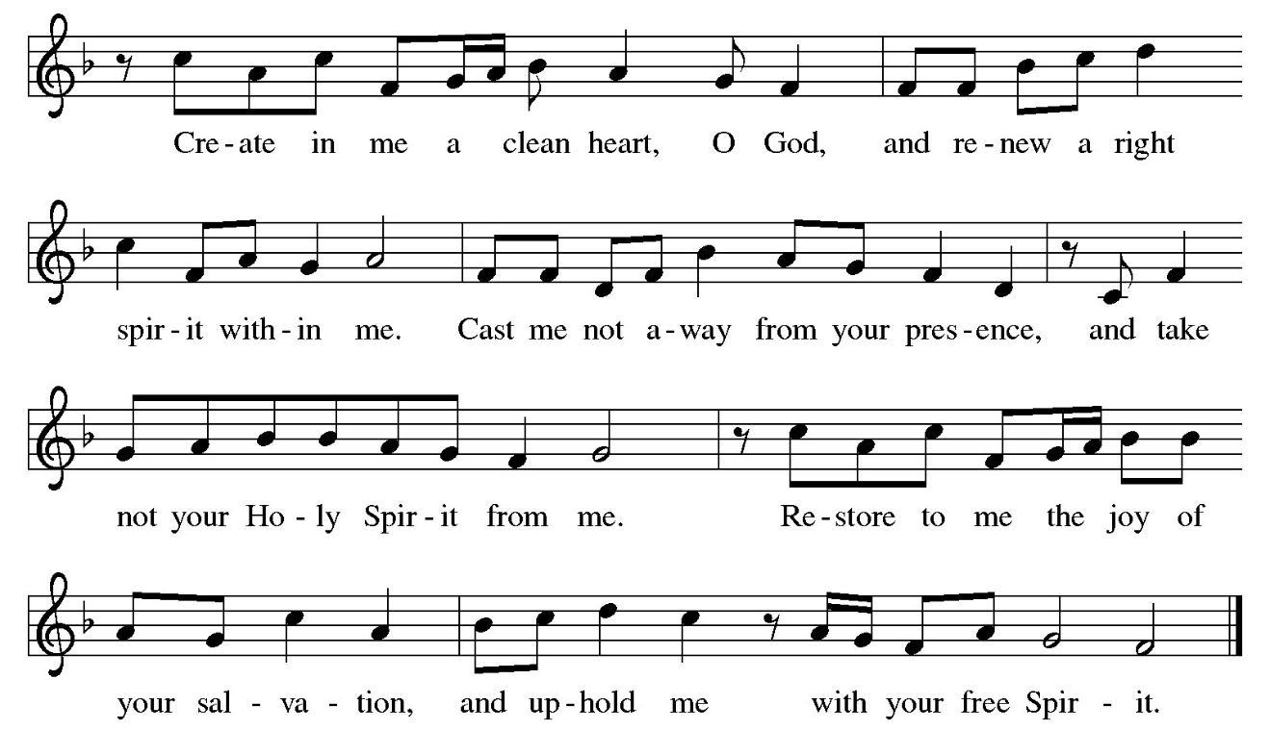

OFFERING PRAYER

Let us pray. (pause)

Loving God,
we offer at your table the gifts of our hearts.
Help us take heart in you and share freely of your love,
so that all creation can taste your abundance.
We ask this in the name of Jesus,
through the Spirit abiding with us now and forever.
Amen.

THE GREAT THANKSGIVING

The Lord be with you.
And also with you.

Lift up your hearts.
We lift them to the Lord.

Let us give thanks to the Lord our God.
It is right to give our thanks and praise.
PREFACE

It is indeed right, our duty and our joy,
that we should at all times and in all places
give thanks and praise to you, almighty and merciful God,
through our Savior Jesus Christ;
who on this day overcame death and the grave,
and by his glorious resurrection opened to us the way of everlasting life.
And so, with all the choirs of angels,
with the church on earth and the hosts of heaven,
we praise your name and join their unending hymn:

HOLY, HOLY, HOLY
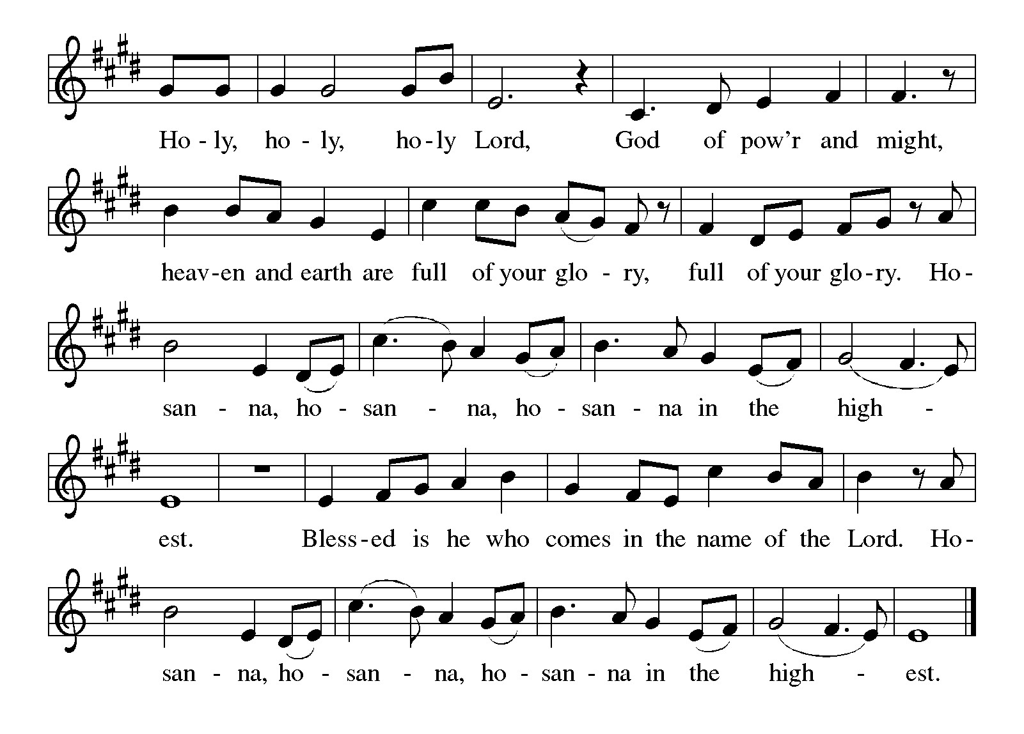

THANKSGIVING AT THE TABLE

In the night in which he was betrayed,
our Lord Jesus took bread, and gave thanks;
broke it, and gave it to his disciples, saying:
Take and eat; this is my body, given for you.
Do this for the remembrance of me.

Again, after supper, he took the cup, gave thanks,
and gave it for all to drink, saying:
This cup is the new covenant in my blood,
shed for you and for all people for the forgiveness of sin.
Do this for the remembrance of me.

THE LORD’S PRAYER

Our Father, who art in heaven,
hallowed be thy name,
thy kingdom come,
thy will be done,
on earth as it is in heaven.
Give us this day our daily bread;
and forgive us our trespasses,
as we forgive those
who trespass against us;
and lead us not into temptation,
but deliver us from evil.
For thine is the kingdom,
and the power, and the glory,
forever and ever. Amen.

Invitation to Communion

Heaven has come near.
Come, share in the feast!

COMMUNION

All are welcome to come to share in Holy Communion at God’s Table.

If it is too difficult to come to God’s Table, please let an usher know and Pastor Nan will bring holy communion to you.

When giving the bread and cup, the communion server says
As you receive the bread and wine:

The body of Christ, given for you.
The blood of Christ, shed for you.
Each person may respond: Amen.

LAMB OF GOD
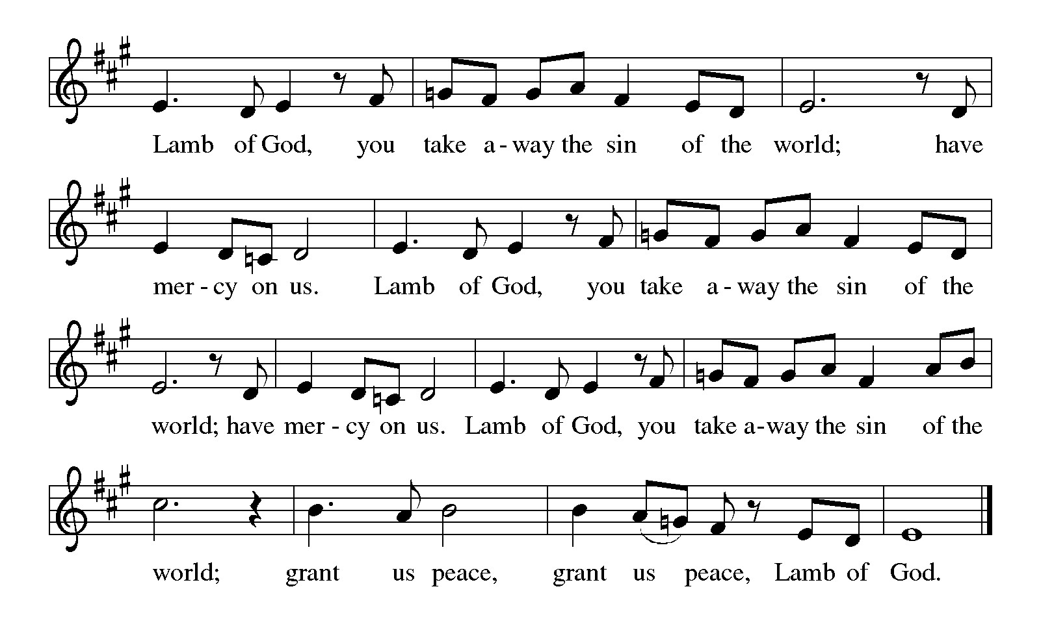

These songs are sung during Holy Communion to help us focus on the Gifts of God for the people of God.

ELW #471
LET US BREAK BREAD TOGETHER ON OUR KNEES

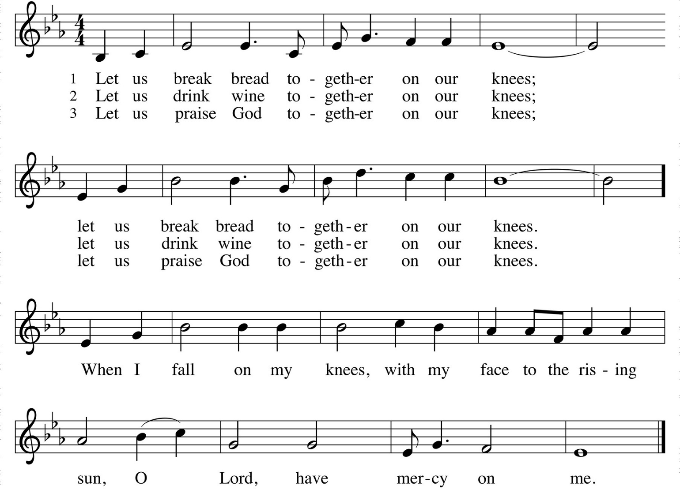
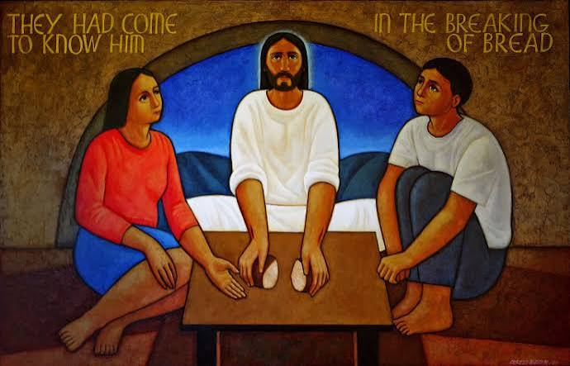
ELW #733 GREAT IS THY FAITHFULNESS

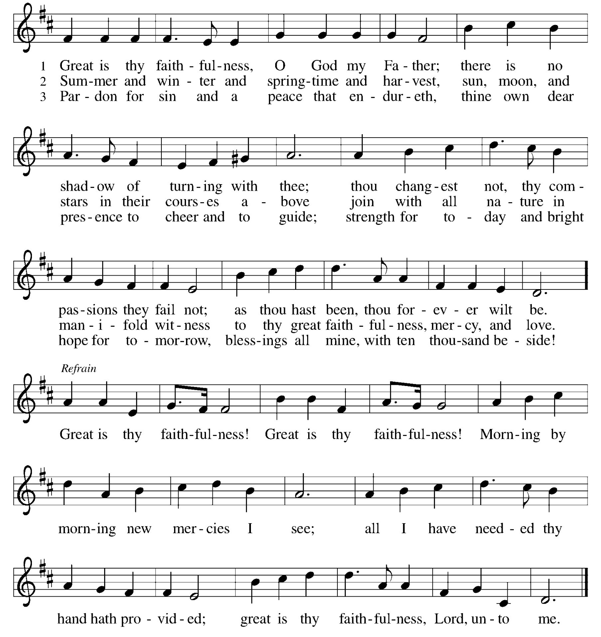

FINAL TABLE BLESSING
The body and blood of our Lord Jesus Christ strengthen you and keep you + in his grace. Amen.

HYMN AFTER COMMUNION
ELW# 857 LORD, I LFT YOUR NAME ON HIGH sing 2 times

Lord, I lift your name on high
Lord, I love to sing your praises
I'm so glad you're in my life
I'm so glad you came to save us
You came from heaven to earth
to show the way
from the earth to the cross
my debt to pay
from the cross to the grave
from the grave to the sky
Lord, I lift your name on high

Prayer after Communion

Let us pray. (pause)

Compassionate God,
through the gifts of bread and wine
our hearts are filled with the abundance of your love.
Strengthen us that we, through this holy meal,
may share your love freely, as you have shared with us.
We ask this in the name of Jesus,
through the Spirit nourishing us now and forever.
Amen.

AFFIRMATION OF CHRISTIAN VOCATION

We are including this in our worship as a witness to our faith in Jesus and in response to Jesus’ priestly prayer (re: John 17. Jesus prays that we be as one.) Within the sending rite of the service, this affirmation may be made by the whole assembly. It comes from our ELCA Worship resources.

People of God, you are chosen and named as God’s beloved. You have received the gift of Christian vocation, a holy calling lived out in various dimensions of your life, your relationships and communities, your work and your rest. Daily and richly, we live in the promises of holy baptism, sustained by grace to trust God, proclaim Christ through word and deed, care for others and the world God made, and work for justice and peace.

I ask you, therefore: Will you endeavor to pattern your life on Jesus Christ, in gratitude to God and in service to others?
Response: I will, and I ask God to help me.

Will you strive to pursue the common good in public life, nurturing mutual care among neighbors near and far?
Response: I will, and I ask God to help me.

Will you pledge to bear witness in word and action, commending what is true and right, renouncing what is unjust and harmful, and working to mend what is flawed?
Response: I will, and I ask God to help me.

Sovereign God, your Son Jesus lived within the structures of society even as he spoke truth to those in power and challenged systems of oppression. Give to your servants courage, patience, and vision in their commitment to serve in Christ’s name. Empower us all in our Christian vocation to be courageous disciples and responsible citizens. Grant that our life in the public realm be grounded in love for our neighbors, care for the most vulnerable, and respect for the common life we share, through Jesus Christ our Savior.
Amen.

GOOD NEWS AND ANNOUNCEMENTS

Blessing

Creator, + Redeemer,
And Sustainer,
Bless, heal, and hold you
Today and always.
Amen.



SENDING SONG ELW #841 LIFT EVERY VOICE AND SING

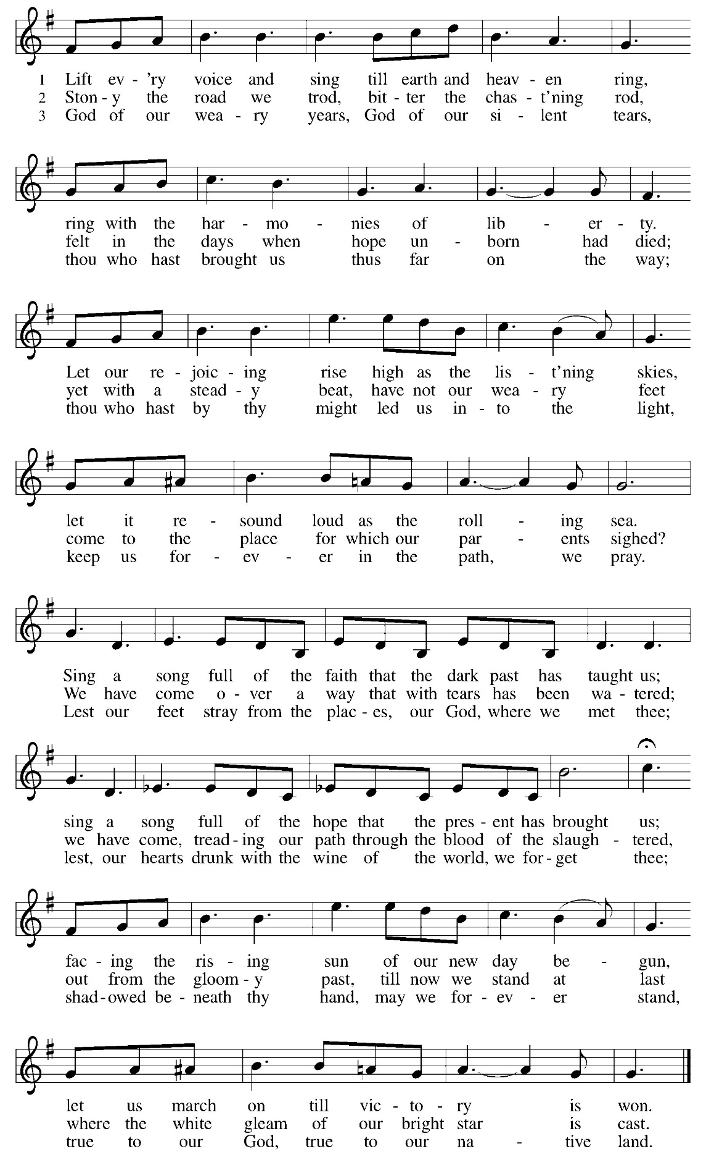
PRAYER BEFORE LUNCH

DISMISSAL

Heaven has come near. Go, share the good news!
Thanks be to God.

PRAYER REQUESTS &
ANNOUNCEMENTS


ST. PAUL HEALING PRAYER LIST

Bob Perdue, Carol Rasmussen, Dennis Dombkowski, Joanne Bryer,
Larry Ross, Leroy Hansen, Lois Davis, Katharine Serviss,
Mary Jean Mallo, Peter Hansen, Shirley Hansen, Shirley Moerdyke,
Shirley Sly, Terri Clark.

***If you want to have someone added, please email the main office, leave a voicemail on the main church phone number or text Pastor Nan

MILITARY

Brian Blomstrom, Chris Miller, Hanah MacMillen, JD Johansen, Marcus Roy, Ryan Treynor, Steve Kowalewicz, Troy Thornburg, Tyler Markum,
Vaughn Misner, Victor Rivera, Vinnie Baza.

PRAYER CHAIN FOR ST. PAUL If you would like to join the prayer chain, please contact Lynn Cooper at 616-754-5579.
This Week

Sunday July 5 930 am Worship with Holy Communion
POTLUCK after worship
ABP class after potluck or at 11 am
Pastor leaves after potluck for two weeks of
Continuing education and the ELCA National
Clergy Gathering

****Coffee Fellowship for July is posted on the bulletin table
JULY Newsletters are available
3rd quarter Christ in Our Home devotion books are out

Monday July 6 5 pm Al-Anon
Building closed

Tuesday July 7 Council Reports are due
10 am Food Mission

Wednesday July 8 No Bonhoeffer book study
5:30 pm Food Mission
Mark Sabbath

Thursday July 9

Friday July 10 1:30 pm Shalom Zoom Meditation
6 pm Bonfire

Saturday July 11 1030 am Eucharistic ministers meeting
No Read with Pastor and Friends

Sunday July 12 930 am worship on the Pavilion
Picnic after worship
ABP class after worship or 11 am
Pastor gone - July 5 after church through July 16
ELCA Pastor Gathering/Continuing Education

JULY SERVING
